**EMPLOYMENT RELATIONS TRIBUNAL**

**AWARD**

**ERT/RN 124/17**

**Before**

**Rashid Hossen - President**

**Vijay Kumar Mohit - Member**

**Rabin Gungoo - Member**

**Ghianeswar Gokhool - Member**

**In the matter of:-**

**ERT/RN 124 /17 – Mr Chitanand Luchman (Disputant)**

**And**

**Mauritius Post Ltd (Respondent)**

This labour dispute was reported by Mr Chitanand Luchman, the Disputant, on 25th July 2017 to the Commission for Conciliation and Mediation with regard to the withholding of his annual increment by his employer, the Mauritius Post Ltd, the Respondent. As no settlement could be reached, the Commission referred the labour dispute to the Tribunal for arbitration in terms of Section 69(7) of the Employment Relations Act 2008 (the Act) “as per enclosed amended Terms of Reference”.

The exact wording of Section 69(7) of the Act reads:-

“*where no agreement is reached in the case of a labour dispute reported by an individual worker, the Commission may, within 7 days, with the consent of the worker, refer the labour dispute to the Tribunal for arbitration.”*

We fail to understand the use of the word ‘amended’ by the Commission in this referral.

The point in dispute is:-

*“Whether the Mauritius Post Ltd should grant me my annual increment that was due to me as from January 2017.”*

Disputant started employment at the postal services on 1st June 1981. Following a survey carried out on 20th December 2016, a shortage of Rs 58,500 was found in his cash holding and which he made good soon after. His explanation was sought and a Disciplinary Committee was instituted although not proceeded with. He made a request on 2nd January 2017 to retire as Senior Postal Executive and same was approved on 11th March 2017. He was granted all his retiring benefits, namely:-

* 210 days vacation leave cash allowance;
* 110 days sick leave cash allowance;
* Passage benefits; and
* Lump sum.

Since he was deemed to be in service till 11th March 2017, he claims that he should have been paid his annual increment due to him as from January 2017.

The Respondent’s case rests primarily on the fact that Disputant had been interdicted to exercise the powers and functions of his duties and was therefore not eligible for such an increment. The Human Resource Executive at the Respondent, Mr Nazeemudin Moraby, testified to the effect that on 20th December 2016, Disputant was in service as Senior Postal Executive and on that day a survey was carried out by the Internal Audit Department. It was discovered that there was a shortage of Rs 58,500 in the cash holding of the Disputant. The Disputant, could not explain the shortage and refunded the money on 21st December 2016, the date a letter of interdiction was sent to him and which reads:-

“…*You are hereby informed that it has been decided to interdict you from the exercise of the powers and functions of your duties as Senior Postal Executive (Postmaster of Vacoas Post Office) with immediate effect until further notice. During your interdiction you will continue to be paid your salary…*”

The witness explained that the word ‘salary’ referred to in the said letter is in relation to basic salary only and does not include any allowances. Since the shortage of money constituted an amount that he fraudulently misappropriated, Disputant was requested to provide his written explanation as to why disciplinary proceedings for gross misconduct should not be instituted against him. The Disputant replied the following in a letter dated 29th December 2016 amongst others:-

*“…I have been in the Postal services for the past thirty five (35) years and am fully aware of my duties and responsibilities. The exact amount of cash holding should be in my custody and being in an unexplicable situation on the spot, in good faith I accepted to make it good to avoid any prejudice to anyone. I had to do so as I strongly feel I have a strong moral obligation towards the company and myself to maintain a high standard of honesty and integrity…”*

Disputant’s request for early retirement with effect from the date the shortage of money was discovered was sent to Management in a letter dated 7th January 2017.

On the 14th March 2017, Respondent informed the Disputant that the Board had approved his request and which document we reproduce here:-

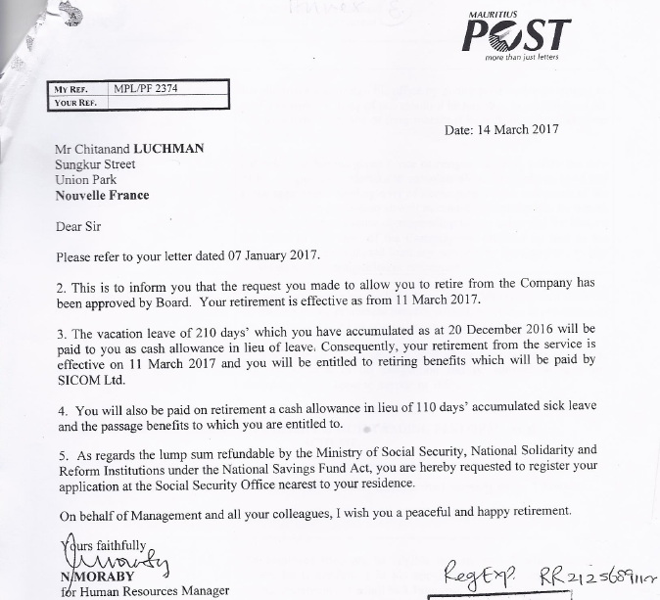

According to the above document, Disputant was deemed to be in service till 11th March 2017.

Section 5 of the **Terms and Conditions of Employment at the Mauritius Post Limited** deals with the "*Annual Salary Increment and Outstanding Performance Scheme*".

Section 5.3 specifically states that "*where the salary of an employee is on an incremental scale, the employee shall not draw the annual increment as of right, but only with the specific approval of the CEO when the latter is satisfied that the employee’s work, work performance and conduct have been satisfactory during the preceding twelve months.*"

Section 5.4 states that "*where the performance of an employee is not satisfactory, the CEO may, on the recommendation of any of the employee’s immediate superiors decide to stop, withhold or defer his increment.*"

Section 5.4.1 states that "*where it is decided to stop, withhold or defer an increment for which an employee would otherwise be eligible, the employee shall be informed in writing of the reason/s well before the increment falls due. The case shall be referred to the Human Resources Department and the reason/s thereof must be recorded during the Annual Performance Review exercise*" (the underlining is ours).1

We are not in presence of any evidence purporting to establish that the performance of Disputant was deemed to be unsatisfactory. There was no hearing that concluded that Disputant was guilty of any act of gross misconduct. Management did not go ahead with the Disciplinary Committee initially set up. Disputant was never informed that his increment was to be withheld. It is clear that the provisions of the Terms and Conditions Manual at the Mauritius Post Limited have not been complied with.

The letter referring to his salary while on interdiction makes no reference to withholding of the increment. Disputant cannot by extrapolation be expected to infer that his increment would be withheld. To surmise such an essential requirement cannot satisfy the condition laid down in Section 5.4.1 of the Terms and Conditions of Employment of the Respondent. Not informing the Disputant in writing shows that the withholding of the increment is tainted with procedural impropriety.

We therefore award in accordance with the Terms of Reference.

On a note of observation, we find it appalling that the Respondent being in presence of a *prima facie* case of embezzlement, chose to allow the Disputant to proceed to a ‘*peaceful and happy retirement*’ instead of referring the matter to the Police for criminal investigation. This cannot be an example of good governance.

**SD Rashid Hossen**

**President**

**SD Vijay Kumar Mohit**

**Member**

**SD Rabin Gungoo**

**Member**

**SD Ghianeswar Gokhool**

**Member**

**28th February 2018**